SPRINT-3

|  |  |
| --- | --- |
| **Team ID** | PNT2022TMID38943 |
| **Project Name** | Smart Waste Management for Metropolitan Cities |

1. Create a IBM cloud account, and login to IBM Watson.
2. Add new device in the ibm Watson .
3. Create a python code, the connect to IBM Watson.

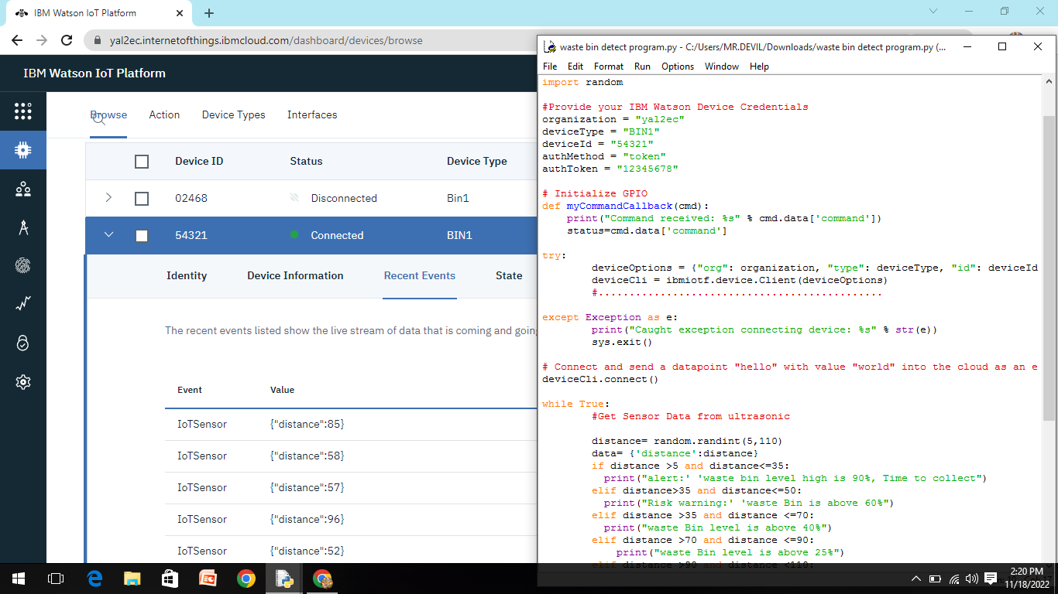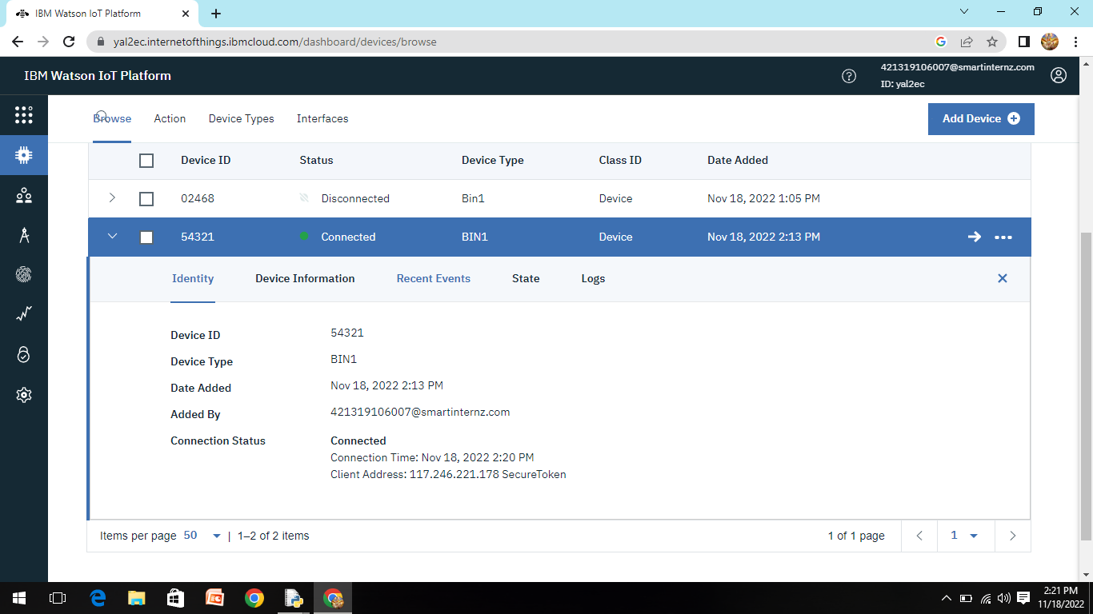

1. Run the python code and see the recent event.
2. Then connect IBM Watson and NODE-RED.

